Cytogenetic techniques :
Cytogenetics is the study of genetic phenomena through the cytological analysis of chromosomes under microscope. Cytogenetic techniques are central to the assignment and localization of genes to chromosomes and thus to the construction of genetic maps. Techniques used include karyotyping, as well as molecular cytogenetics such as fluorescent in situ hybridization (FISH).
Eukaryotic nuclear genome is constituted of discrete linear chromosomes and apparently, a segregational device for cell division. Each chromosome is made up of a single long linear DNA molecule associated with different protein molecules. It provides a framework structure for linkage groups, allows replication, transcription and transmission of genetic information. Each species is characterized by a precise number of chromosome in the nucleus. Plants show great diversity in chromosome number. In a well-documented work, lowest chromosome number has been reported as 2n = 4 in Haplopappus gracilis [7] and in several other species . Highest chromosome count is known from a fern Ophioglossum reticulatum as n = 720.
Light microscopic observation of metaphase chromosomes reveals three distinct features: centromere (primary constriction), nucleolar organizing region (secondary constriction) and telomere at the two free ends of linear chromosomes. Position of centromere determines the shape of the chromosome. Chromosome shape can be metacentric, submetacentric, acrocentric and telocentric depending upon the position of centromere along its length.
Development of staining procedures of root tip squash method and observing condensed chromosomes at metaphase stages have led to the popularity of analysing chromosomes for various cytogenetic studies.
1. Karyotype:
Levitsky proposed and developed the concept of karyotype. It is defined as phenotypic appearance of somatic metaphase chromosomes complimenting their genic content. In a simpler term, karyotype is the number and appearance of chromosomes at somatic metaphase stage. Diagrammatic representation of karyotype is often termed as ideogram or karyogram. Karyotype analysis has helped in the identification of individual chromosomes within a genome. Such studies have been undertaken in diverse group of plants over past several decades. These data have been useful in evolutionary and phylogenetic studies at taxonomic level between species and family. With conventional staining methods, it has not been possible to differentiate all the chromosomes in a karyotype of several groups of plants and animals.
Chromosome banding:
Various chromosome banding methods were developed after 1960s, which produced transverse dark and light bands along the length of chromosomes. These banding methods are widely used for the identification of individual chromosomes in the karyotype, detection of structural changes in chromosomes, aneuploid identification, chromosome polymorphism and genome analysis of polyploids. Various chromosome banding methods that are reported in usage in plants and animal species are Q-, G-, C-, R-, T-banding. Among these banding methods, Q- and C-banding are widely used in plants.
Types of banding:
Cytogenetics employs several techniques to visualize different aspects of chromosomes.
G-banding is obtained with Giemsa stain following digestion of chromosomes with trypsin. It yields a series of lightly and darkly stained bands — the dark regions tend to be heterochromatic, late-replicating and AT rich. The light regions tend to be euchromatic, early-replicating and GC rich.
R-banding is the reverse of G-banding (the R stands for "reverse"). The dark regions are euchromatic (guanine-cytosine rich regions) and the bright regions are heterochromatic (thymine-adenine rich regions).
C-banding: Giemsa binds to constitutive heterochromatin, so it stains centromeres. The preparations undergo alkaline denaturation prior to staining leading to an almost complete depurination of the DNA. After washing , the remaining DNA is renatured again and stained with Giemsa solution consisting of methylene azure, methylene violet, methylene blue, and eosin. Heterochromatin binds a lot of the dye, while the rest of the chromosomes absorb only little of it. The C-banding proved to be especially well-suited for the characterization of plant chromosomes.
Q-banding is a fluorescent pattern obtained using quinacrine for staining. Most part of the stained DNA is heterochromatin. Quinacrin binds both regions rich in AT and in GC, but only the AT-quinacrin-complex fluoresces. Since regions rich in AT are more common in heterochromatin than in euchromatin, these regions are labelled preferentially.
T-banding: visualize telomeres.
Features of Karyotype:
Six features of karyotype are recognized and compared.
(i) absolute size of chromosomes, (ii) position of centromere, (iii) relative size of chromosome, (iv) basic chromosome number, (v) number and position of satellite, and (vi) degree and distribution of heterochromatin. Analysis of karyotype helps us in identifying each chromosome pair in the chromosome complement.
Construction of Karyotype and Idiogram:
About 15–20 complete metaphase plates with well-spread clear chromosomes from three to eight individuals from each population are analyzed. Obtain photo prints of 10 metaphase plates and select 5 plates for measurements of chromosomes. Karyogram is prepared by arranging chromosomes in decreasing order.
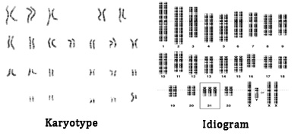

2. Fluorescence in situ hybridization (FISH):
Fluorescence in situ hybridization (FISH) allows visualization of the physical position of a specific DNA sequence in chromosomes or a nucleus spread on microscope slides. FISH results show cytological features of the distribution and organization of DNA sequences in chromosomes, providing an opportunity to study chromosomes at molecular level. This method involves hybridization of a specific DNA sequence (probe) onto the complementary DNA (target) spread on slide and visualization of the hybridization sites as fluorescent signals.
FISH Technique:
The basic procedure of FISH involves four parts: (1) preparing the specimen spreads on slides (target), (2) preparing and labeling the probe, (3) hybridizing the probe to the target, and (4) visualizing fluorescent signals.
In fluorescence in situ hybridization (FISH) , the probe is hybridized directly to DNA within the cell. The probe is a small segment of DNA that has been labeled with fluorescent tags in order to be visualized. The target DNA is located within the cell and requires some special processing. The target cells may be the preparation of metaphase chromosome which has been air dried on a microscopic slide and in which the DNA has been denatured with formamide. The fluorescently labeled probe hybridizes to complementary sequences in the DNA and when the cells are illuminated at the appropriate wavelength, the probe location on the chromosome can be identified by fluorescence.
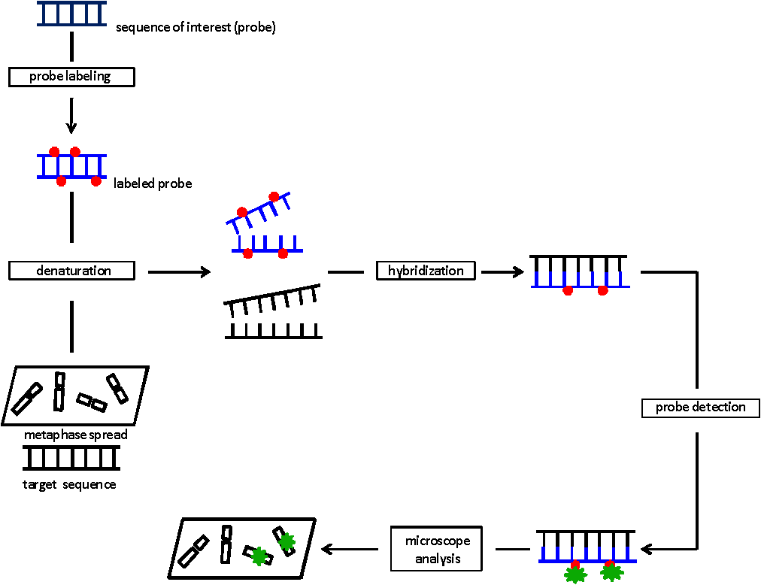
Diagrammatic representation of Fluorescence In Situ Hybridisation

